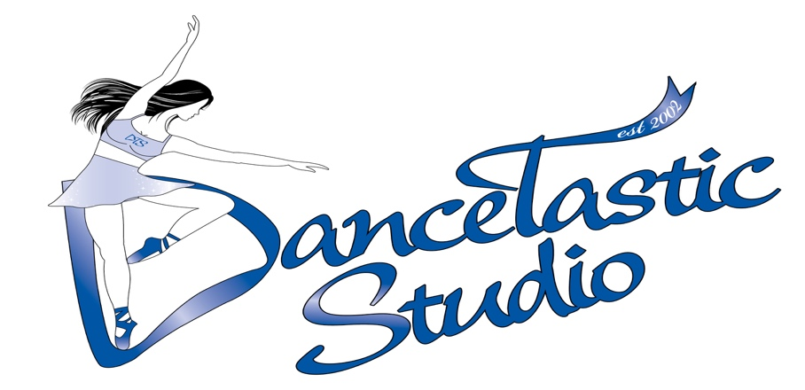FALL NEWSLETTER
September/2017

Attention Parents & Dancers:

Welcome to DanceTastic Studio (DTS), the “Total Package” studio. We are excited to start our 2017/2018 season, and would like to take this opportunity to welcome you. At DTS we pride ourselves in being a top provider of dance education and we are thrilled about the diverse and talented staff on board this year. Joining the dance program at DTS will enrich your child’s life. Our classes will provide the dancers with a sense of commitment and pride, introduce new friendships, and encourage teamwork. We want to thank you for choosing DTS, and look forward to a fun and successful season.

Student Mail Boxes
All recreational students are assigned a mailbox at the beginning of the dance season. The mailboxes are located in the lobby, in a wooden filing cabinet which is situated directly below Studio 1, closed circuit camera. The competitive students’ do not have a mailboxes this season, we are going paperless. All communications will be through email, or on our MEMBERS section of our website.

Administrative Information
If you haven’t already submitted the total amount owed to DTS for the full dance season via post-dated cheque or debit card as of November 2nd, 2017 your account will be charged a 15% late fee. Please visit the office to make payment arrangements. The final drop date to be eligible for DTS’ no-hassle money back guarantee is December 1st, 2017 (we’ll refund the unused portion of your fees, minus a $50.00 administration fee).

Wireless Internet Access
DTS has invested in WIRELESS INTERNET for the convenience of students doing homework during scheduled breaks between dance classes and for parents doing work while waiting for their child to finish a dance class. Please feel free to bring your devices to the studio as you can access the Internet in the main lobby. The network is dance studio 3 and password for wireless access is: dancers1

Closed Circuit Camera System
DTS has invested in 2 state of the art closed circuit cameras for both Studio 1 and Studio 2, for your convenience. Parents can sit back, relax and view their child’s weekly progress in dance. All monitors will stay on for recreational classes. For competition classes the choreographers will decide whether or not to turn on the monitors.

Video Surveillance Cameras
Please be advised that DTS now has video surveillance cameras covering all areas of the building (interior/exterior) including hallways, waiting room, office, studios, front and back door.

Regular Attendance
We always want to stress the importance of regular attendance, which allows your child to progress and obtain the full experience for advancement to the next dance level. Please be sure to call the office if your child is going to be absent from the class at (905) 709-6092. Please note DTS does not offer any make-up classes for missed lessons.

Class Punctuality
Arrive on time! DTS recommends that you arrive at least 5 minutes prior to classes starting, so you have enough time to change and line up against the wall outside Studio 1 or 2. This allows for a smooth transition for your child/ren. Most importantly late arrivals disrupt the flow of each class.

Classroom Entrance and Exit Procedure
At DTS we want the pickup and drop-off of children for their dance lessons to go as smoothly as possible. Therefore, we ask that parents do not gather in the small hallway that leads to the dance studios. This area is where dancers line up before their classes begin. Dancers are expected to line up against the wall 5 minutes prior to the class commencing in order for classes to begin on time.

Class Cancellations
Safety is a number one concern at DTS. Therefore, in the case of detriment weather, classes may be cancelled. This policy is adopted to ensure that dancers, parents/caregivers, and teachers remain safe in going to/from class. Please call the studio and listen to the pre-recorded message or visit our website (www.dancetastic.ca) for news in regard to any class cancellations. Please be advised that there are no makeup classes. All Class Schedules are subject to change without notice or penalty.

Proper Attire
It is important that all dancers come to class dressed appropriately, the uniform colour is black. If your child/ren have long hair please remember to tie it back in a ponytail and/or ballet bun out of their face. If your child has short hair please use bobby pins or a headband to keep it off of their face.

Hands on Adjustments
Please note that in order to properly correct the student during classes it may be necessary to physically touch/adjust the child’s shoulder, arm, hip, knee, back, foot etc. This is outlined in the DTS waiver which can be found on the Registration Form.

DTS Environment
Please help us keep the DTS environment tidy, by remembering to take your water bottles out of the studios, keeping the change room dry (especially in winter), storing your shoes in your cubby, leaving the studio with any belongings you came with. The Lost and Found Bin can be located in the front hallway (second floor) underneath the table.

Dancers are not allowed to chew gum in the studio. If you are chewing gum when you come in, put it in the garbage! Do NOT leave it under a table or on the floor!

DTS Takes Precautions Against the Flu
Cold and flu season is upon us. In order to maintain a healthy dance environment this season, DTS will be taking simple precautions to prevent the spread of flu viruses. To help stop the spread of the illness all students, teachers, and parents must:
- Wash hands frequently with soap and hot water (especially in-between classes)
- If hands are not visibly dirty, waterless alcohol-based hand gels containing at least 60% alcohol can be effective in removing germs. (Hand sanitizers are located in Studio 1, Studio 2, the reception area, and the change room)
- Keep hands away from your eyes, nose and mouth
- Cover your nose and mouth with a tissue when you cough/sneeze or sneeze into your arm, not your hands.
Symptoms of the flu viruses include fever (102-104°F), cough, sore throat, headache, body aches and fatigue. If your child experiences any of these symptoms DanceTastic Studio recommends that the student stay home to keep from infecting others.

2017/2018 Important Dates
- Recreational and competitive technique classes commence Monday, September 11th, 2017 and ends Saturday, June 1st, 2018
DanceTastic Studio will be closed on:
- Thanksgiving Day- Monday October 9th, 2017
- December Holidays-Monday December 25th, 2017 to Sunday January 7th, 2018 (final class before Holidays is Saturday December 23rd, 2017. The first day back is Monday January 8th, 2018)
- Family Day- Monday February 19th, 2018
- March Break- March 12th to March 18th, 2018. (Final class before Break is Saturday March 10th, 2018. The first day back is Monday March 19th, 2018)
- Good Friday- Friday March 30th, 2018
- Easter Monday-Monday April 2nd, 2018
- Victoria Day-Monday May 21st, 2018
Year End Showcase & Dress Rehearsals (Competitive & Year End)
- Tickets for our Showcase go on sale on Monday April 23rd, 2018 @ 10:00am. Richmond Hill Centre for the Performing Arts Box Office Info: 10260 Yonge Street, Richmond Hill 905 787 8811Online Box Office: www.rhcentre.ca
- Competitive Dress Rehearsal: Tuesday March 6th, 2018 Richmond Hill Centre for the Performing Arts from 4:30pm to 10:00pm
- Competitive Picture Day TBA
- Recreational Picture Day TBA
- Year End Showcase Dress Rehearsal “Dance To The Music, 2018” will be held at the Richmond Hill Centre for the Performing Arts, on Thursday May 31st, 2018.
- Our Year End Showcase “Dance To The Music, 2018” will be held at the Richmond Hill Centre for the Performing Arts on Friday June 1st, 2018 (6:45pm evening showcase) and Saturday June 2nd, 2018 (12:45pm Matinee showcase).
RECREATIONAL COSTUME COSTS
All Recreational Costume Costs are due in full at the time of registration. Post-dated cheques (prior to December 1st, 2017) must be submitted on the first day of classes. If payment is not received by this due date it is assumed that the child will not be participating in the Year End Showcase “Dance To The Music 2018” and no costume will be ordered or measurements taken for the child.

If it is decided that the child does not want to participate in the Year End Showcase and payment has been received and the office has been notified in writing by December 1st of the year of the recital, all costume deposits will be refunded in full. There will be no refunds issued after December 1st, 2017.

All Jazz/Acro/Ballet costumes cost $135.00 (includes HST); Primary/Jr/Hip Hop costumes cost $90.00 (includes HST); and Inter/Sr Hip Hop costumes cost $95.00 (includes HST).

NSF CHEQUES AND POST DATED CHEQUES
Please be advised that all NSF cheques returned by the bank will be subject to a $50.00 handling charge. In the event of an NSF cheque, “certified cheques” will be required for all future payments. Any “post-dated” cheques that have been previously submitted to the office for payment, which require a “change of deposit date,” must have requests submitted in writing at least 24 hours in advance. There will be a $5.00 charge for this service. If there are any remaining questions please do not hesitate to contact the office. On behalf of all staff at DTS, we hope you enjoy the dance season!

DTS COMPETITIVE COMPANY MEMBERS

Online Competitive Student Communication Board
DTS has opened an online competitive student communication board. This board can be accessed by competitive students and their parents via the website. Any pertinent information regarding competitions and workshops will be posted there.
Instructions:
- Please visit www.dancetastic.ca
- Click on the members heading (seen at the top of the web page)
- Enter Username: dancetastic
- Enter Password: fantastic
*Attention parents and students please keep username/password confidential. This information is for DTS Competitive Company Members only
Important Reminders:
- All required payments for lessons (post-dated cheques) and costume deposits (Dated Oct 1st: $150.00/per costume) should be submitted to the office.
- Competitive Jackets are required and are to be worn at each Competition. Please see the office to request your orders!
- Proof of Age should be given to the office as soon as possible. We accept a copy of the child’s health card or other photo ID so long as it has the child’s picture and date of birth.
- Chokers & Earrings are also required for competitions. Please order in office.
- Class Changes: Please advise office of any class changes that you have made or need to make (ie. Dropped/added a class). If you have the Limitless package promotion, please note that if you fall beneath the 8 class minimum you will automatically pay regular prices as you are no longer eligible for promotion.
- All dance shoes must be clean and “hole” free
- Dance Competitions: All Competition Students must perform in all dance competitions chosen by the studio (Competitive Weekend dates to follow)
- Technique/Ballet/Stretch Classes: All Competition Students must participate in all technique AND stretch/strength classes offered by DTS for their level

DTS LIMELIGHT DANCEWEAR
Our DTS Competition Team Jackets are available for purchase from the office. The jacket is available in a “fitted” or “bomber” styles. In order to receive your TEAM jacket PRIOR TO DTS Competitive Season FULL PAYMENT AND ORDER FORM MUST BE SUBMITTED TO THE OFFICE NO LATER THAN December 1st, 2017. The Cost of the dancewear is $125.00 (plus HST $16.25) for Bomber or Fitted Jackets. Total Cost is $141.25

Rac & Roll Bags
Durable bags which can stow competitive costumes and makeup are available for purchase. Please see Lauren Middup (DTS staff member) to order your very own Rac & Roll Bag.

Hangers
DTS is in need of clothes hangers for competitive and recreational costumes. If you have any extra hangers lying around at home please bring them into the office.

If you have any questions, please feel free to contact the office at 905-709-6092 or come in to speak to our office administration.

Sincerely,

DanceTastic Studio Management (DTS) Learn…Live…Love….Dance

